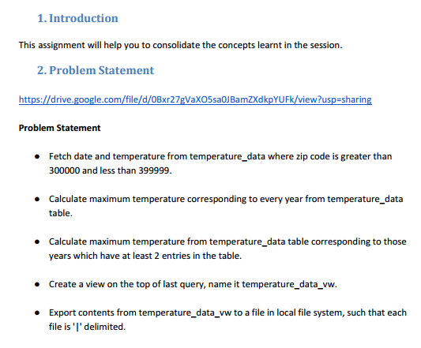

**Creating databases**

first we will create a database where we will create our views and tables, using following

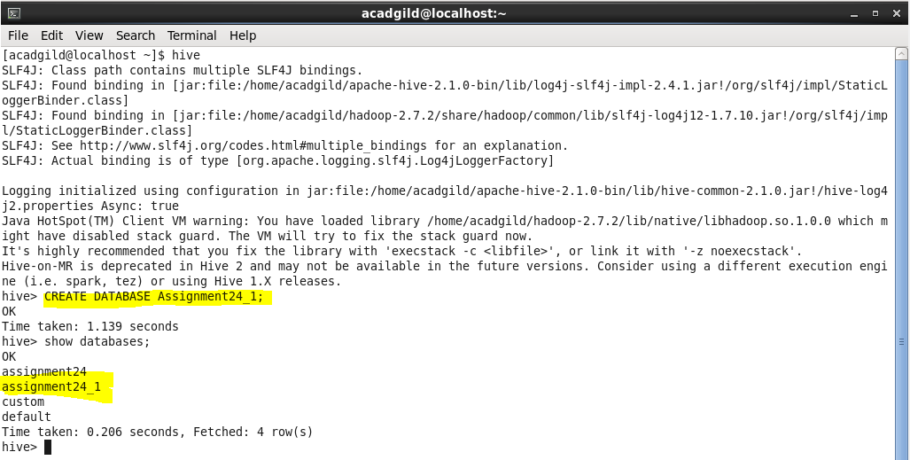

**Creating table**

Now using create command we will create temperature table



**Loading data**

Now we will load our data file that is temperature_data into our temperature table as

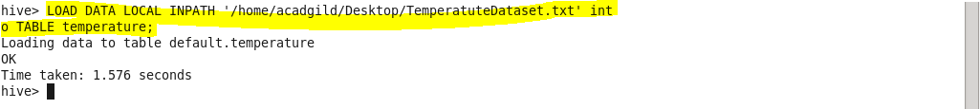

So now using select command we can see the data inside the table

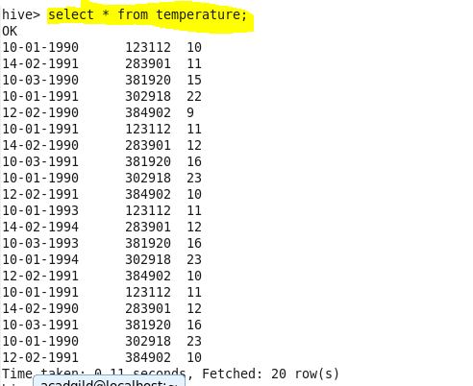

**Q.1. Fetch date and temperature from temperature_data where zip code is greater than 300000 and less than 399999.**

For this particular problem we will select the date and corresponding temperature from our table and will insert a where condition, where zip code should be in between 300000 and 399999

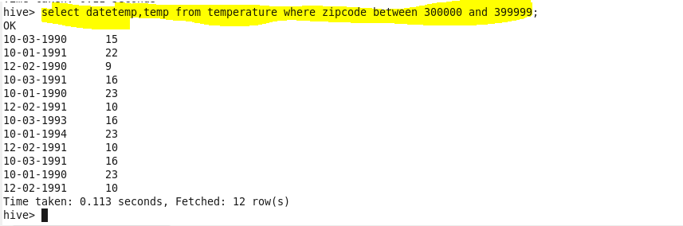

**Q.2. Calculate maximum temperature corresponding to every year from temperature_data table.**

Now for this particular problem we will extract the year using substring method and will use max function so as to find out the maximum temperature for that particular year. And then we will group our result by year

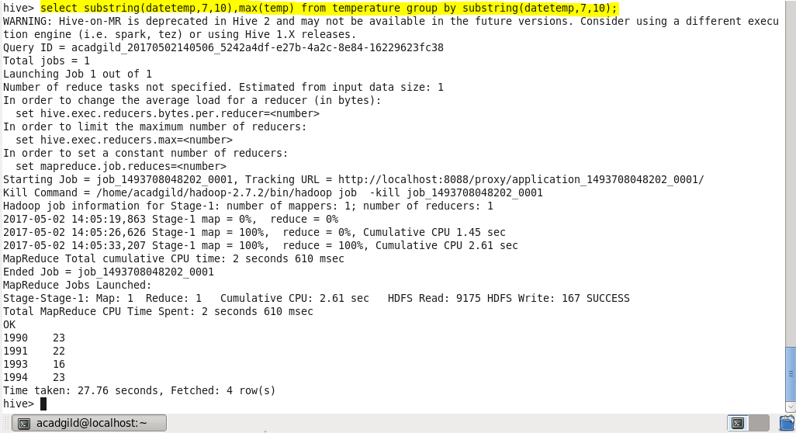

**Q.3. Calculate maximum temperature from temperature_data table corresponding to those years which have at least 2 entries in the table**

Now as we want to calculate maximum temperature from the table corresponding to years which have at least 2 entries so will use count function so as to check the number of entries greater than 1 and as count is an **aggregate function** so we will using **having** for our condition

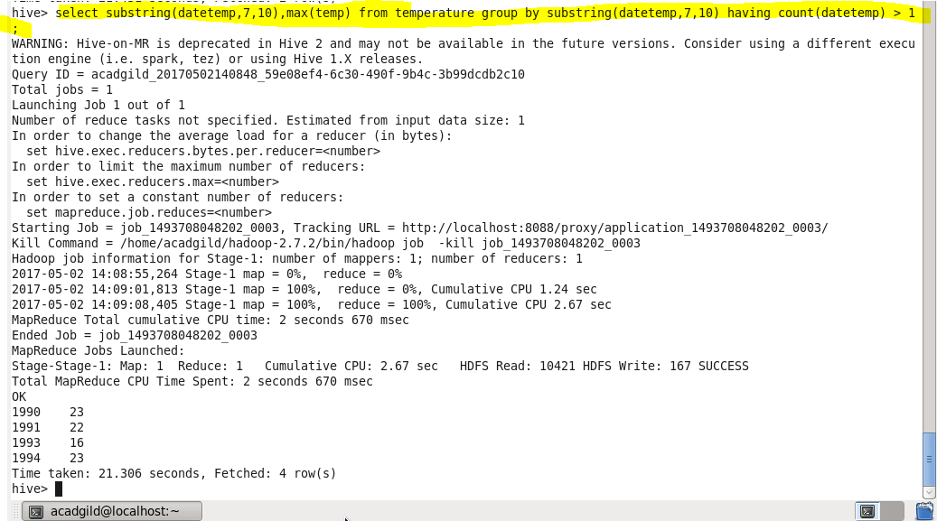

**Q.4. Create a view on the top of last query, name it temperature_data_vw.**

Now using create view command we will create view on the top of previous query



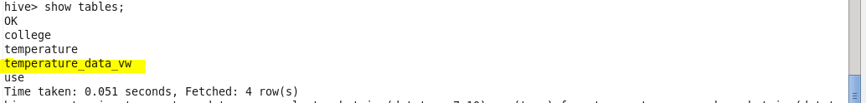

**Output**

Now using select query we can see the data in our view

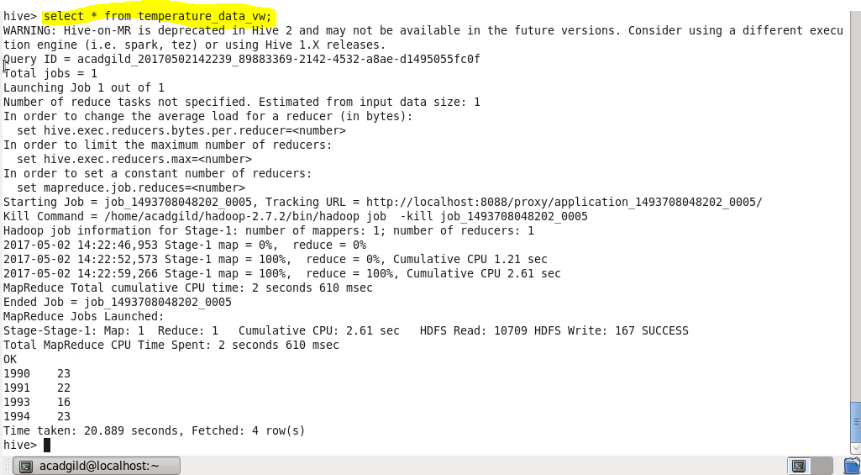

**Q.5. Export contents from temperature_data_vw to a file in local file system, such that each file is '|' delimited.**

Now we will use insert command so as to export our contents from view to a local file.

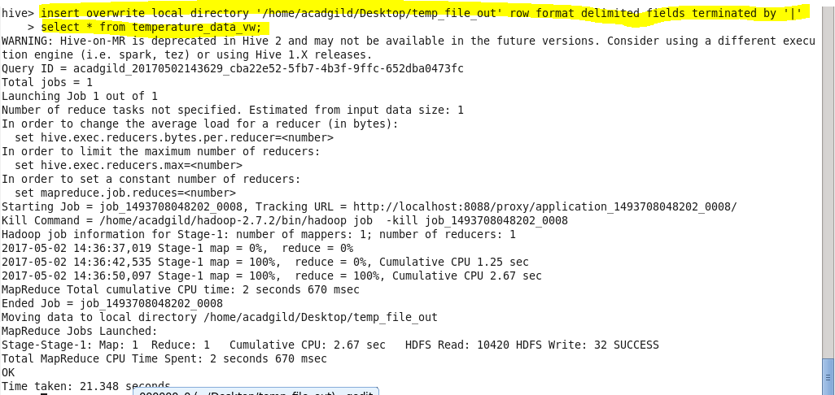

**We can see the data in our local file**

